Wanneroo Secondary College

Year 12 Mathematics Specialist Unit 4

Test 5 2019

Calculator-Free Section

You are only allowed the SCSA formula sheet for this section. Any question worth more than 2 marks requires sufficient working to justify your solutions.

**Time : 20 Minutes Marks : 17**

**1. [2, 3 = 5 marks]**

A particle moves with velocity where is it’s displacement. The particle is initially 2 m to the right of the origin.

a) Show that the particle has constant acceleration

b) Determine the displacement, , as a function of time, .

**2. [1, 2, 4 = 7 marks]**

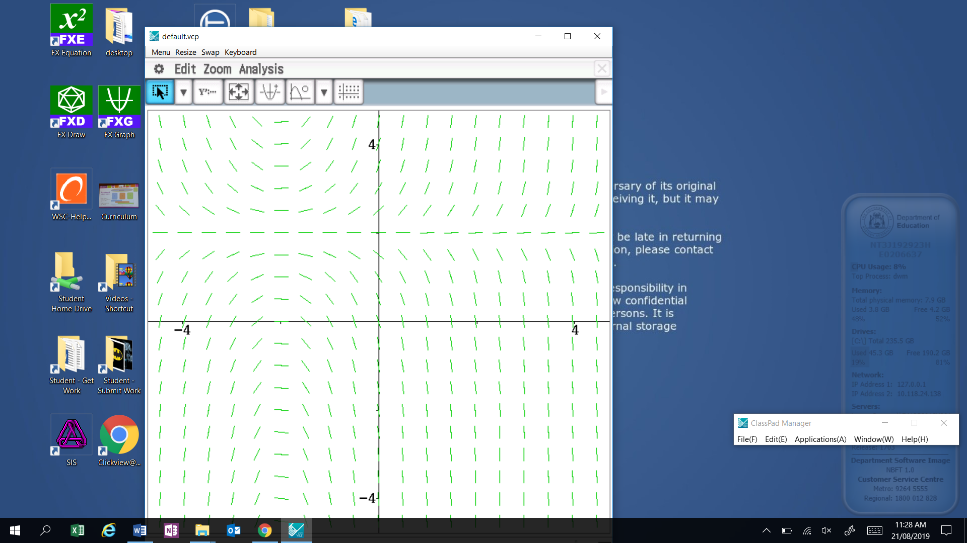

a) Circle the differential equation that best matches the slope field shown:

i) ii)

iii) iv)

b) Determine the value of the slope field at the point (2, 3) and draw the solution on the slope field above.

c) Determine the equation of the particular solution curve that passes through the point (2, 3)

**3. [5 marks]**

Determine the gradient of the tangent to the curve at the point (1, 1)

Wanneroo Secondary College

Year 12 Mathematics Specialist Unit 4

Test 5 2019

Calculator-Assumed Section

You are allowed the SCSA formula sheet, approved calculator(s) and one page of A4 notes (back and front) for this section. Any question worth more than 2 marks requires sufficient working to justify your solutions.

**Time : 35 Minutes Marks : 33**

**4. [3, 2 = 5 marks]**

After seconds, the displacement centimetres of a small mass attached to a spring, oscillates about a fixed point according to the differential equation .

The initial velocity is 15 centimetres per second and the initial displacement is zero.

a) Determine the function that gives the displacement of the mass at time

b) Calculate the distance the mass travels during the first 3 seconds.

**5. [2, 3 = 5 marks]**

A dog’s drinking bowl is formed by revolving the curve , , through 360 about the y-axis. The units of and are in centimetres.

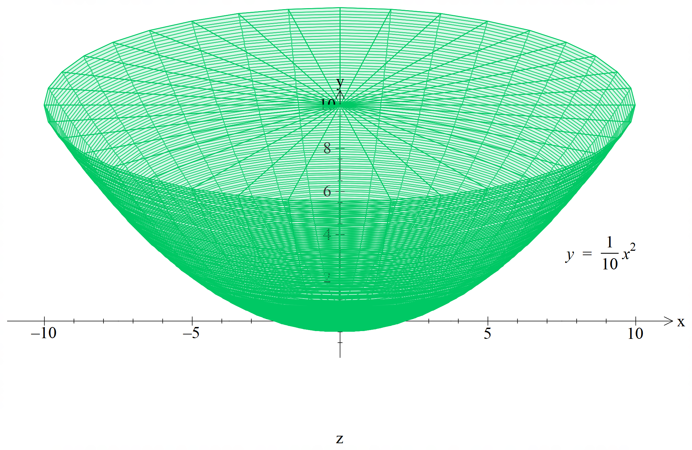

a) Show the expression connecting the height of water in the bowl and the volume of water in the bowl is given by

b) The bowl is filled with water at a rate of 50mL per second. At what rate is the height of the water increasing at the time when the bowl contains 600 mL of water?

**6. [7 marks]**

Determine the values of the constants and if is a solution of the differential equation

**7. [6, 4 = 10 marks]**

An ecology student is studying the repopulation of wild emus in Western Australia after a drought. She notices that the population growth rate is approximately logistic so that where is the population years after her study begins.

The carrying capacity is known to be 2550 emus, since this was the population before the drought.

Initially, the student finds that there are 310 emus. After 2 years she finds there are 390 emus.

a) Given that , use the separation of variables technique to determine the equation to find the population after years

b) Find the time at which the population growth rate is a maximum.

**8. [3, 3 = 6 marks]**

The graph of is shown below:

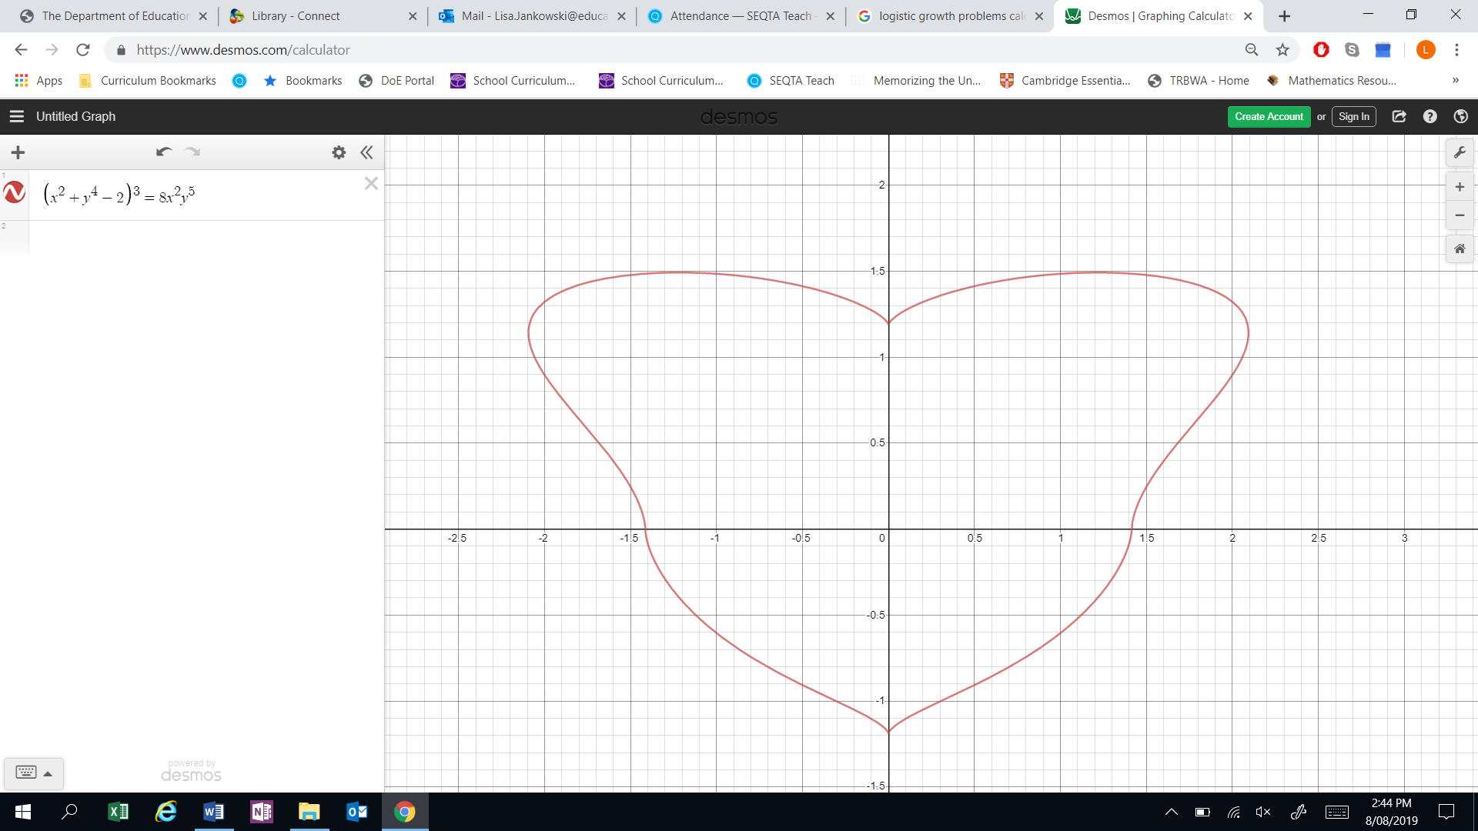

a) By implicitly differentiating the given equation, obtain an equation relating and .

Note: Do not attempt to obtain as the subject of this equation.

b) Determine the coordinates of the point on the graph in the first quadrant ( where the gradient is horizontal.